Lesson 4 e&c Switched on | 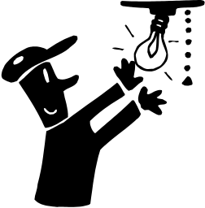

AIM OF THE LESSON

During this lesson students will:
- Explore the concept of flow of electricity in simple circuit and how this can be controlled using switches.
- State that adding more batteries make globes shine brighter.


EQUIPMENT

Per Class
- masking tape
- a bag of lollies e.g. M&Ms

Per Group
- 2 D batteries (1.5 volts) per group
- 3 lengths (15cms) of insulated copper wire with about 1cm of insulation removed at each end
- 1 small globe (have spares)
- pop sticks for supporting batteries
- blu-tac
- alfoil
- 4 drawing pins
- 4 large paper clips
- 2 split pins
- 1 sponge cut in half (optional for extension)

Preparation
- Extension: cut sponges in half and cut a small square from the middle of each using a Stanley trimmer. The squares should be a uniform size i.e. 3cm x 3cm.
Safety
- Mains electricity must not be used.

Background Information for teachers

- Electrons flow from the negative end of the battery.
- As each electron move through a conductor, it pushes on the one ahead of it, such that all the electrons move together as a group.
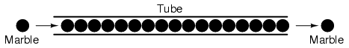
- The tube is full of marbles, just as a conductor is full of electrons. If a single marble is inserted into this full tube on the left-hand side, another marble will immediately try to exit the tube on the right.
- Light globes consist of a glass bulb, which has a filament in between the two wires which go into and out of it. The filament is made from a very thin wire, which has a high resistance to electricity.
- This resistance causes the filament to heat up and glow when electricity passes through it.
- The electric current travels along the wire, enters the filament, heats up the filament, creates light and exits the globe through the other wire.
- The light that is seen from the light globe is the glow of the filament.
- Voltage e.g. 1.5 volts is a measure of how much energy each electron is given by the battery.
- A pressure switch is shown below that is suggested in the extension activity.
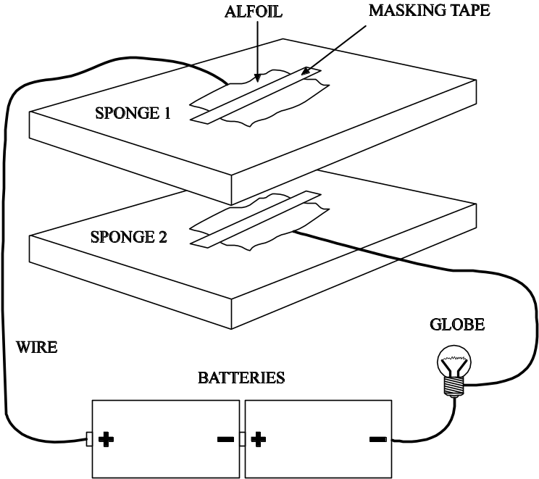


Lesson Outline

- Introduction (Engaging Students)
- Take students outside.
- Have all students stand in a circle arms distance apart. They are the carriers of electricity (electrons). They release their arms once in position.
- Nominate two students to be the battery, they form an arch with their arms held high for students to walk though.
- Nominate a student to stand next to the battery and hold a bowl of M&Ms or similar at the edge of the circle.
- Nominate two students to be the light, they form an arch with arms together out at waist height. Students need to bend down to pass through.
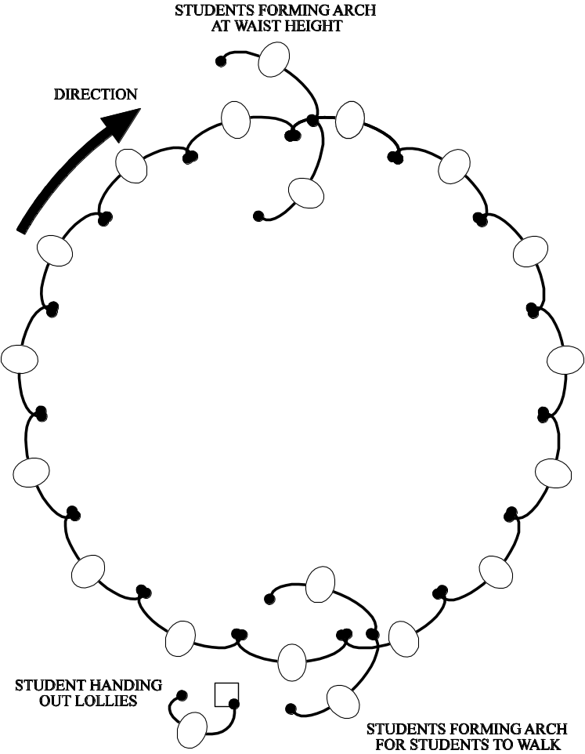

  - The students are given an M&M as they pass the battery as energy. They then use some of this energy to get under the arch of the light and they must keep some of the M&M in their mouth to make it back to the battery to be given more energy. The students must walk around the circle and always stay an arms width apart.
  - This represents the flow of electricity in a simple circuit.

What did you represent in a circuit?  Why did you have to bend down to pass through the globe.  What did the lollies represent? | The carrier of electricity (tiny particles called electrons).  Energy is lost in the globe as light and heat.  The energy supplied by the battery. Chemical energy that you get from your food.

2. Activities and Strategies
- Write down the aim, equipment and method for the activity.
- Students to set up a circuit using two batteries, one globe and three wires until they get the globe to light up.
- Tape the working circuit onto the desk or a sheet of card. (optional but makes it easier to alter the circuit).
- Design a switch that will work using the materials provided and any others in pencil cases.
- Determine where to place the switch and connect it into the circuit.
- Draw a labelled diagram of the switch.
- Attempt to make two other switches and draw these.
- Select the best three switches for students to demonstrate to the class.

- Focus Questions (Explain and Elaborate)

Describe the path of the electricity?  Why do we have switches in circuits? | From the battery through the circuit (switch and globe) back to the battery.  To stop the flow of electricity.

How does a switch work?  What safety switches do you have at home? | The metal joins up the circuit allowing electricity to pass through.  Circuit breakers, which cut out electricity when there is too much passing through. These are also seen on a smaller scale on power boards with multiple outlets.

- Reflection
  - Write a conclusion to explain why switches are needed in circuits and how they work.
  - Select some students to read their conclusion to the class.


Extension Activities

- Construct a circuit that has two different paths for electricity to flow through.
- Design a pressure switch using a sponge and some alfoil.


Links to other learning Areas

- Use an electricity bill to calculate the daily, weekly and monthly cost of electricity in your home.
- Create a song about electricity.
- Write 10 quiz questions with answers to test your friend’s knowledge about electricity.
- Role-play how you could save energy at home.
- Write a story with the title ‘The night the lights went out’. Include in your story the problems faced by people and possible solutions.
- Research some of the early inventors of electricity and electrical items such as light globes and batteries.

ACTIVITY 4 : SWITCHED ON | 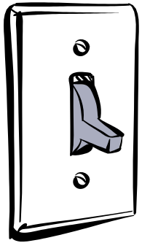
Aim (What are we going to find out?)

Equipment (What do I need to complete the task?)

Method (How is the task to be done?)

Results (What did I observe?) Draw a labelled diagram of your switches.

Conclusion (What did I learn about the flow of electricity and switches?)

